Sermon Outline September 27, 2015

Experiencing God
WHAT DOES IT MEAN TO EXPERIENCE GOD?

Today we start a journey called Experiencing God. What does that mean? Does it mean we will see God with our eyes? Does it mean we will get a special sense of his presence? Does it mean we will experience miracles?

To answer the question, think about a person you know very well. What kind of experience did it take to get to know them that well? Did you just have to see him or her? No. Was it enough to get into his or her space? No. Did you just have to receive something from that person? No. In order to know a person in the full sense of the world, we have to receive their promise and act on it in faith. That’s how we really get to know someone.

The same is true about God. If you want to experience God in such a way that you know him, don’t wait until you lay eyes on him. By then it will be too late. Don’t look for an experience or an event where you feel his presence. And don’t demand a sign or a miracle. Instead, look for his promises and act on them in faith.

Hebrew 11:6 says, … without faith it is impossible to please God, for whoever would draw near to God [and know him] must believe that he exists and that he rewards [or keeps his promises to] those who seek him.

The Experiencing God journey is designed to lead us into a deeper experience of God so that we get to know him for who he is. It does that by tuning us into God’s promises and challenging us to act on them.

This journey is built around the seven realities illustrated in this diagram.

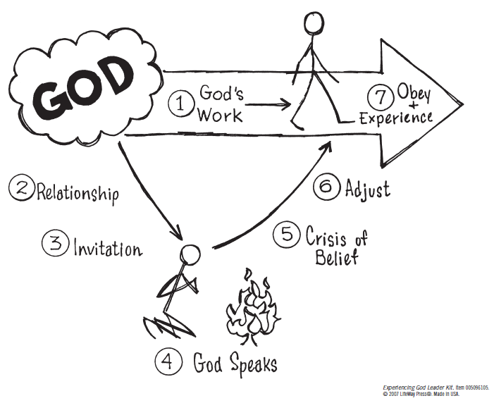

The first work that God wants to do in anyone’s life is to draw that person into relationship with himself. In order to accept God’s invitation for relationship with himself, the first thing we must do is trust the promise of the Father’s love and purpose for us (Jer. 29:11; John 3:16). The next thing we must do is trust the promise of his forgiveness and redemption through Jesus Christ (1 John 1:9). One more thing we must do is trust the promise of the Holy Spirit (John 14:16-18).

Seek the LORD while He may be found
Call upon Him while He is near

